Supporting Information
Table S1. Correlation matrix among the signal-free tree-ring chronologies for the common period (772 AD – 1975 AD, n = 1204). All correlations are significant at 95% confidence.
 | AYA | AAG | HUI | PTY | AAR | QUI*
LEN | 0.5 | 0.73 | 0.67 | 0.71 | 0.65 | 0.34
AYA |  | 0.67 | 0.68 | 0.32 | 0.36 | 0.14
AAG |  |  | 0.75 | 0.53 | 0.61 | 0.35
HUI |  |  |  | 0.52 | 0.44 | 0.18
PTY |  |  |  |  | 0.64 | 0.34
* Common period 772 – 1918, n = 1147

Table S2. Weather stations used to calculate a regional mean maximum temperature record for the period 1959-2009.

Weather station | Latitude / Longitude | Elevation | Period | Source
 | (S) (W) | (m.a.s.l.)
Pichoy Airport Valdivia | 39°39' / 73°04' | 21 | 1960 - 2016 | DMC¹
Universidad Austral Valdivia | 39°48' / 73°15' | 10 | 1960 - 2010 | UACH²
Cañal Bajo Osorno | 40°36' / 73°09' | 61 | 1959 - 2016 | DMC
El Tepual Puerto Montt | 41°26' / 73°05' | 85 | 1960 - 2016 | DMC
Isla Teja Valdivia | 39°48' / 73°15' | 13 | 1851 - 1883 | Carlos Anwandter³
¹ Dirección Meteorológica de Chile
² Universidad Austral de Chile
³ Carlos Anwandter instrumental record
Table S3. Correlation Matrix among mean annual maximum temperature records (January-December) for the period 1960-2009. All correlations are significant (p < 0.05).
 | U. Austral Valdivia | Cañal Bajo Osorno | El Tepual  Puerto Montt
Pichoy Airport Valdivia | 0.76 | 0.82 | 0.93
Universidad Austral Valdivia |  | 0.53 | 0.73
Cañal Bajo Osorno |  |  | 0.85

Table S4. Correlation Matrix among mean summer maximum temperature records (December-March) for the period 1960-2009. All correlations are significant (p < 0.05).
 | U. Austral Valdivia | Cañal Bajo Osorno | El Tepual  Puerto Montt
Pichoy Airport Valdivia | 0.88 | 0.89 | 0.85
Universidad Austral Valdivia |  | 0.78 | 0.86
Cañal Bajo Osorno |  |  | 0.80

Table S5. Correlation between 4-month periods of mean summer maximum temperature and tree-ring width from the adjusted and non-adjusted chronologies for the 1959-2009 period. Significant correlations (p < 0.05) are indicated in red.
Period |  | Non-adjusted Chronology | Adjusted Chronology
From | Through
pJan* | pApr | -0.21 | -0.25
pFeb | pMay | -0.23 | -0.23
pMar | pJun | -0.18 | -0.13
pApr | pJul | -0.07 | -0.03
pMay | pAug | 0.06 | 0.02
pJun | pSep | 0.12 | -0.01
pJul | pOct | 0.16 | 0.02
pAug | pNov | 0.26 | 0.15
pSep | pDec | 0.00 | -0.02
pOct | Jan | -0.16 | -0.15
pNov | Feb | -0.30 | -0.33
pDec | Mar | -0.47 | -0.70
Jan | Apr | -0.36 | -0.41
Feb | May | -0.25 | -0.26
Mar | Jun | -0.15 | -0.11
Apr | Jul | -0.07 | -0.03
May | Aug | -0.02 | -0.05
Jun | Sep | -0.04 | -0.14
Jul | Oct | 0.00 | -0.10
Aug | Nov | 0.07 | 0.03
Sep | Dec | 0.01 | 0.03

* p indicates the previous growing season.
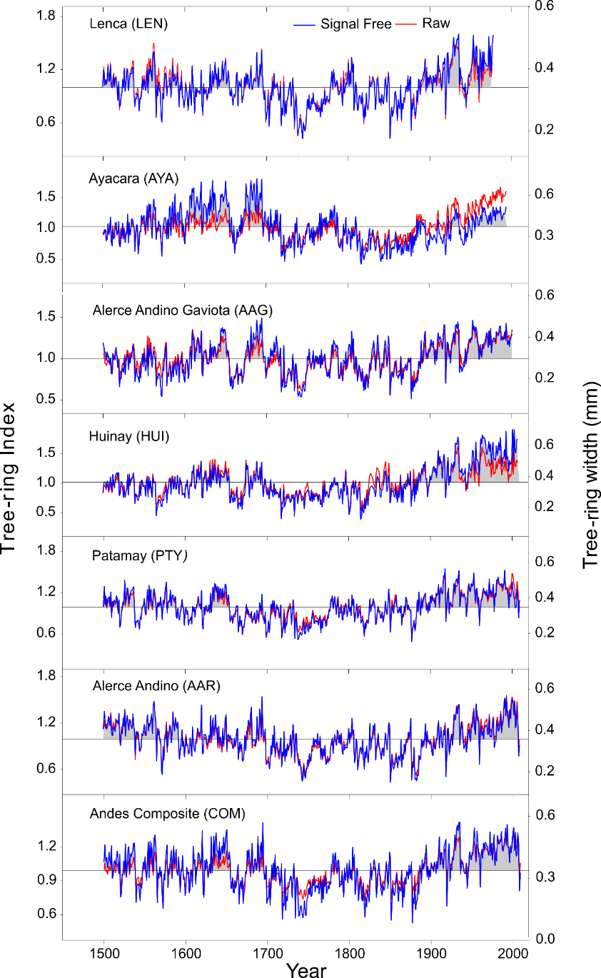
Figure S1. Comparison of Fitzroya raw and standardized (Signal Free Method) tree-ring chronologies since 1500. The composite chronology is depicted at the bottom. The grey shading below the standardized chronologies indicates tree-ring indices above the mean and highlights the positive trend in most of the chronologies since 1900. Quildaco (QUI) chronology was not included since it only reaches up to 1918.
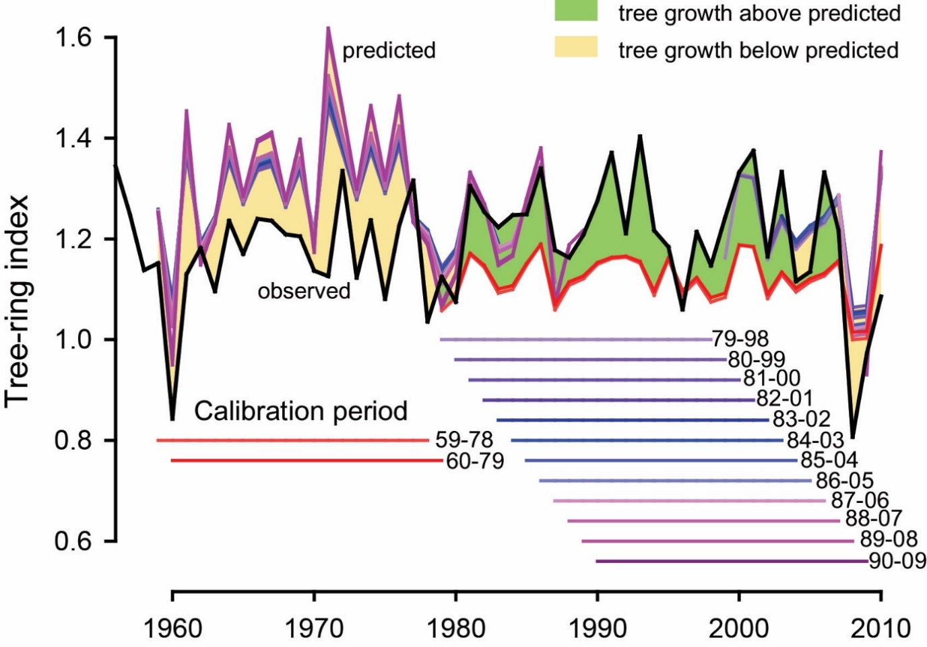

Figure S2. Diagram depicting the differences between observed (black curve) and predicted tree growth (different colours) using mean maximum temperature as the independent variable. Different moving 20-year calibration periods lagged 1 year over the 1959-2009 period are shown. Only the periods when the regression models explained more than 25% of the variance are depicted, and these were used to predict growth in the remaining 31-year period. Differences between observed and predicted growth were related to differences in mean intrinsic water use efficiency (iWUE) between the calibration and prediction intervals.

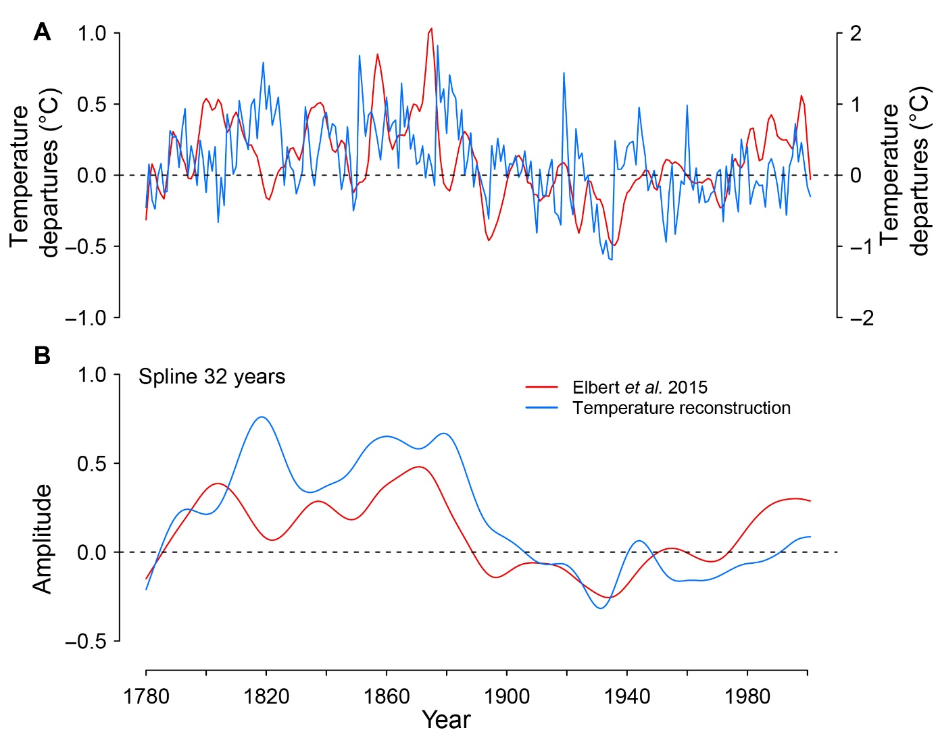
Figure S3. (A) Comparison between our mean maximum summer temperature reconstruction and the mean spring-summer temperature reconstruction for 47° S from varved sediments from El Plomo Lake (Elbert et al., 2015) for the 1780-2009 period. The Pearson correlation coefficient was r = 0.22 (P < 0.001); (B) Comparison between both records using a 32-year spline to highlight (decadal and multidecadal) frequency variability.
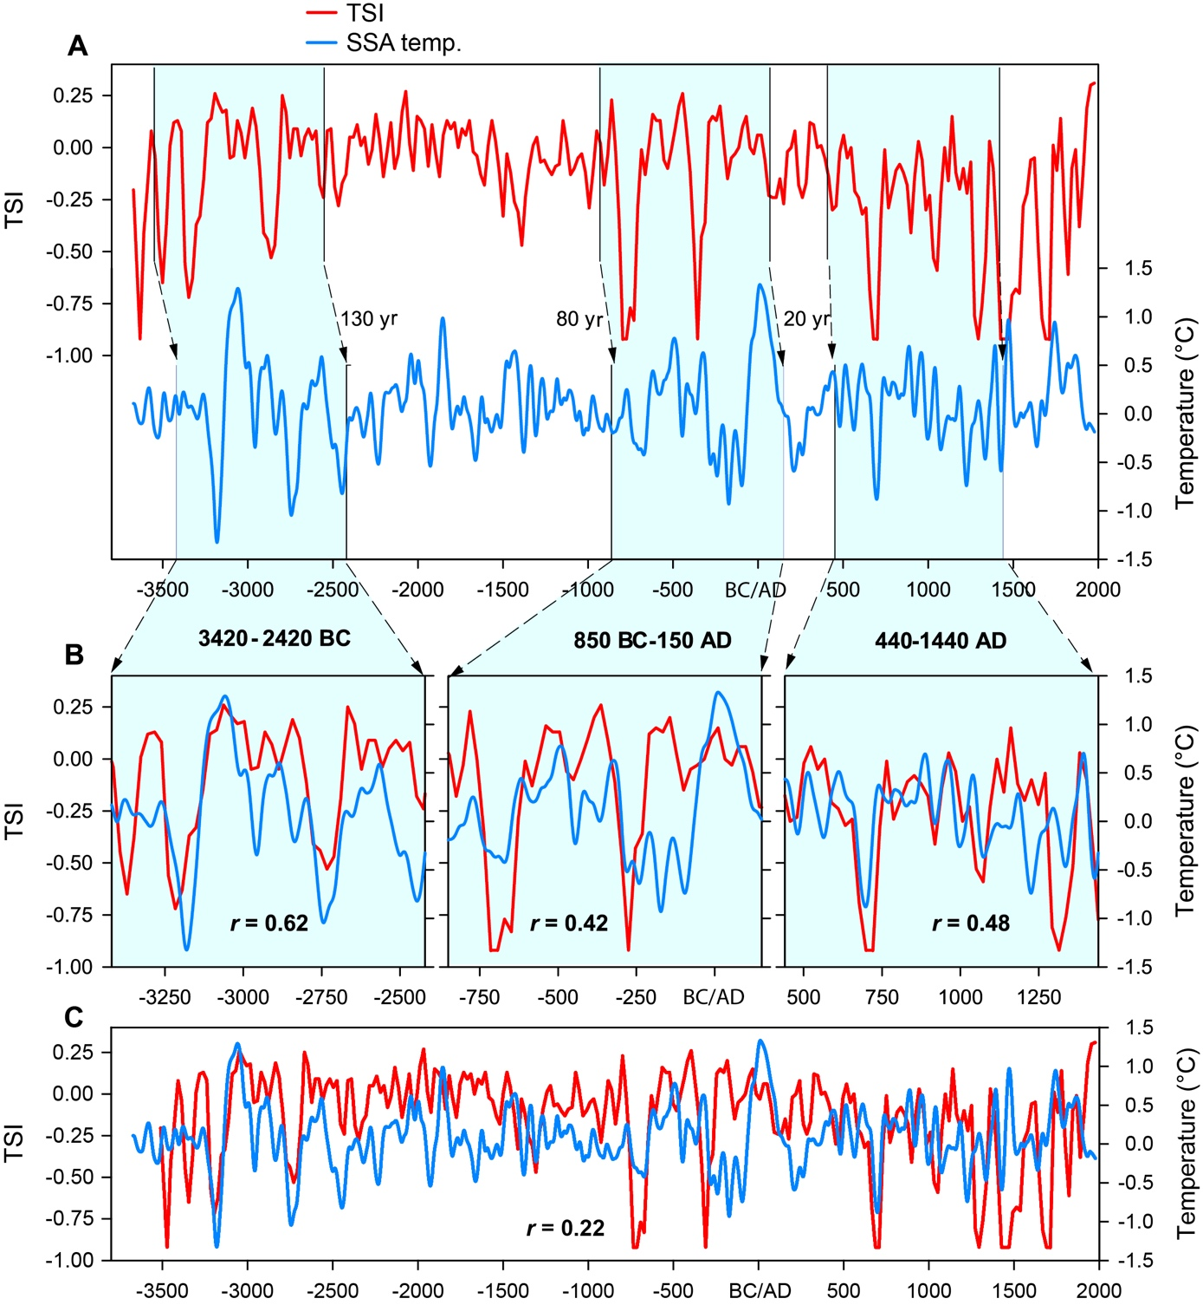
Figure S4. (A) Visual comparison of the temperature reconstruction for SSA and the TSI record (Steinhilber et al., 2012) showing an increasing off-set between both; (B) Comparisons for selected 1.000 year-periods showing common patterns between both records, when the TSI reconstruction is moved back 20 years respect to the temperature record for the 440 - 1440 AD period, 80 years for 850 BC - 150 AD, and 130 years for the 3420 BC – 2420 BC intervals; (C) Comparison between the long-term variations of the SSA temperature and the TSI record after an accumulated linear adjustment for the TSI temporal scale deleting ~3 years per century before 757 AD was applied. The overlapping period between both records is 3672 BC – 1977 AD.
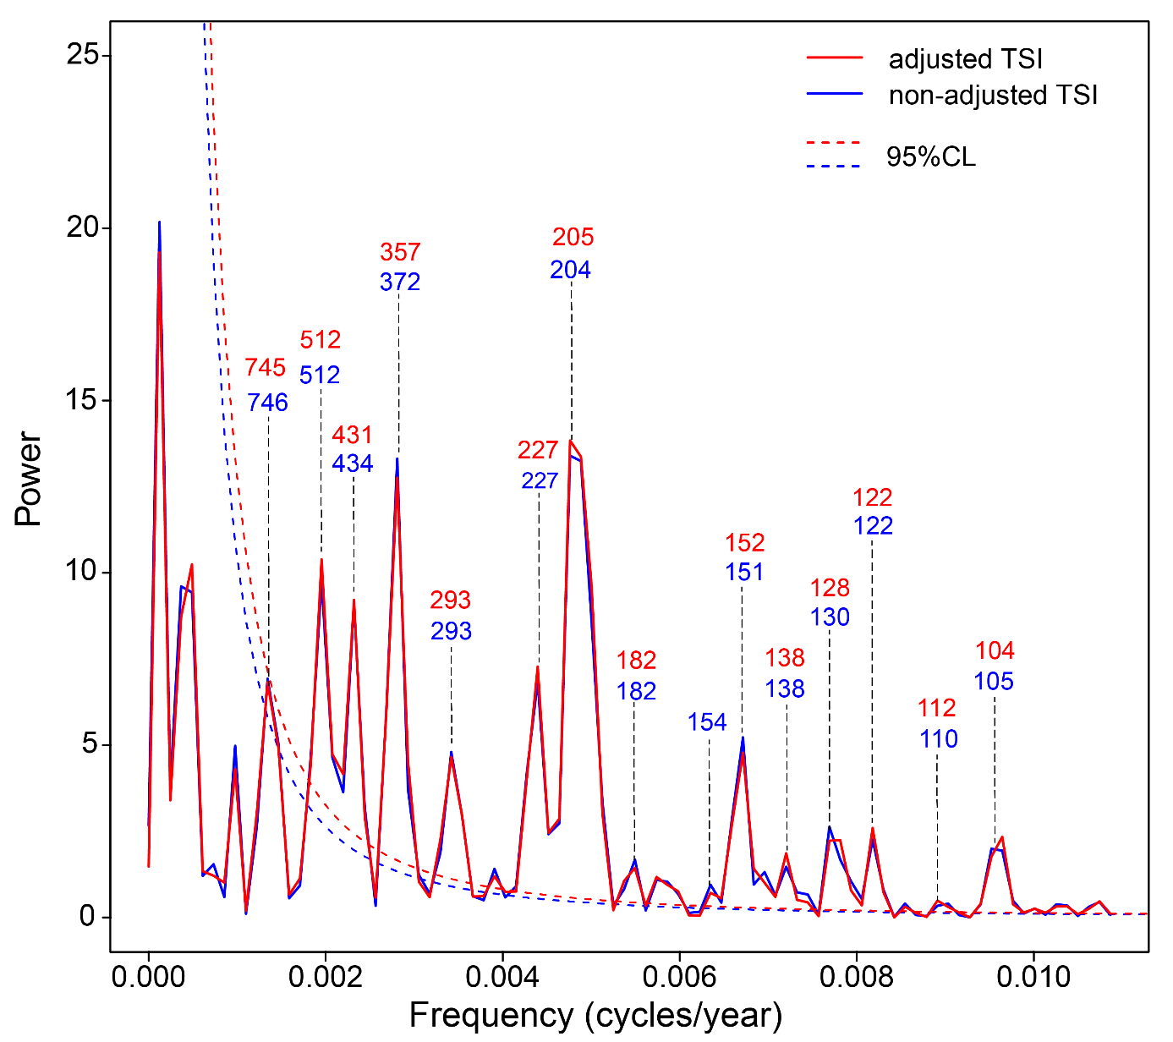
Figure S5) (A) Significant cycles identified by the Multi-Taper Method (MTM, Lees & Park, 1995) for the adjusted and non-adjusted total solar radiation record (TSI, Steinhilber et al., 2012), showing the spectrum for cycles > 100 years.

