Tercera Reunión Científica Anual CR2 y Primera Evaluación in situ
Santiago, 8 y 9 de Junio de 2015. Facultad de Ciencias Físicas y Matemáticas de la Universidad de Chile
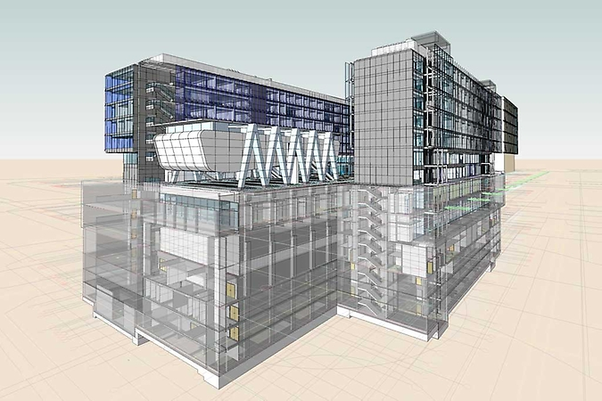

Beauchef 851 (Ver https://vimeo.com/101436985)

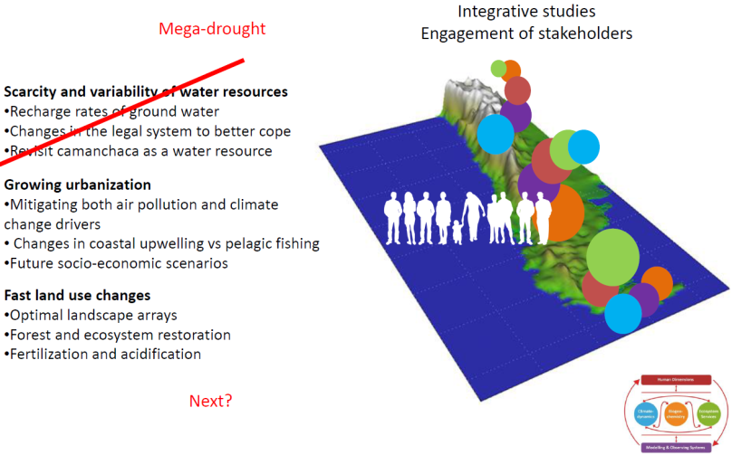

Contenidos

Contenidos 2
Logística 3
Agenda 4
Objetivos principales 4
Objetivos Secundarios 4
Domingo 7/6: Traslados 4
Lunes 8 5
Martes 9 6
Mapa detallado de ubicación en la Facultad de Ciencias Físicas y Matemáticas 8
Panel Evaluador Externo 9
Invitad@s 10
Participantes del CR2 en las reuniones del8 y 9 de Junio 11
Inv. Principales 11
Inv. Asociad@s 11
Inv. Adjunt@s 11
Post doctorand@s 12
Estudiantes/Ayudantes 12
Personal de Apoyo 13
Temas integradores (interdisciplinarios) según la propuesta en Mayo 2012 14
Water scarcity in Northern and Central Chile 14
Urban sprawl in Central and Southern Chile 15
Fast land-use changes in Central and Southern Chile 16
Itinerarios 17
Valdivia 17
Concepción 17
Valparaiso 18
Punta Arenas 18
Temuco 19
Logística
- Dónde: Facultad de Ciencias Físicas y Matemáticas de la Universidad de Chile
  - Día 8 Principalmente Beauchef 851
  - Día 9 Principalmente Departamento de Geofísica de la Universidad de Chile
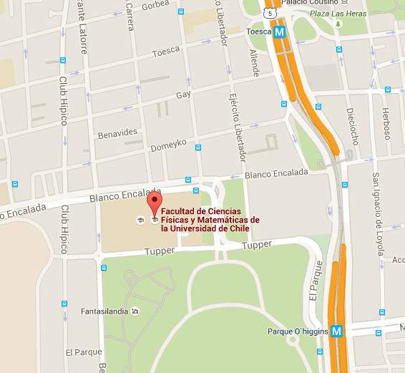
- Quiénes: Investigadores/as del Centro en calidad de investigadores principales, asociados, adjuntos, post doctorales, estudiantes y asistentes. Ver lista de participantes.
- Traslados:
  - Buses Cama desde y hacia Valdivia (Ver itinerarios)
  - Avión desde y hacia Concepción (Ver itinerarios)
- Alojamiento
http://www.rentahome.cl/en/ubicaciones/ejercito/
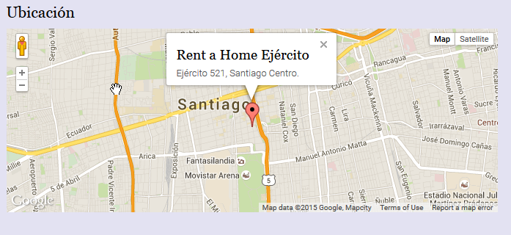

Contactos:

Claudia Isla (cisla@dgf.uchile.cl, 56 2978 4311, cel 92264727
Nicole Tondreau (ntondreau@dgf.uchile.cl, 56 2978 4446, cel 66473419

Agenda

Objetivos principales
- Iniciar la discusión respecto del siguiente tema integrador e interdisciplinario
- Presentarnos ante la evaluación del panel nacional internacional definido por CONICYT

Objetivos Secundarios
- Sostener reuniones de trabajo por línea y estamento
- Revisar la marcha del centro

Domingo 7/6: Traslados

Lunes 8
- Estado de avance del CR2 e inicio de discusión respecto de tema interdisciplinario siguiente, ¿“urbanización” o “cambio de uso de suelos? Ver antecedentes en los extractos adjuntos de la propuesta.
Inicio | Fin | Actividad | Dónde
9:30 | 10:15 | Bienvenida, estado de avance (o no) del CR2 y lo que dijimos de temas transversales en la propuesta. Laura Gallardo | Beauchef 851, B05
10:15 | 10:30 | Instrucciones y preguntas para discusión en grupos. Rosa Osorio. | Beauchef 851, B05
10:30 | 12:15 | Discusiones en grupo | Cafetería del Salón D’Etigny (Habrá café, té, etc.)  Beauchef 851, B05
12:15 | 13:00 | Presentación de los grupos de discusión (Primera parte) | Beauchef 851, B05
13:00 | 14:30 | Almuerzo | Salón D’Etigny, Beauchef 851
14:30 | 14:50 | ¿Por qué el próximo tema puede ser “Cambio de uso de Suelos”?. Antonio Lara | Beauchef 851, B05
14:50 | 15:10 | ¿Por qué el próximo tema puede ser “Urbanización”?. Laura Gallardo | Beauchef 851, B05
15:10 | 15:30 | ¿Cómo discutir “urbanización” vs “cambio de uso de suelos”?. Rosa Osorio | Beauchef 851, B05
15:30 | 17:15 | Discusiones en grupo | Cafetería del Salón D’Etigny (Habrá café, té y refrigerios)  Beauchef 851, B05
17:15 | 18:00 | Presentación de los grupos de discusión (Segunda parte). Modera: Rosa Osorio | Beauchef 851, B05
18:00 | 18:15 | Resumen del día. Laura Gallardo | Beauchef 851, B05

Martes 9
- Presentaciones de nuevos post doctorandos
- Evaluación externa del CR2
Inicio | Fin | Actividad | Dónde | Quiénes
9:00 | 09:00 | Llegada de la Comisión al Centro | Geofísica 5° piso, Blanco Encalada 2002 | 5 personas
09:00 | 11:30 | Laura Gallardo presenta informe del segundo año. Discusión con evaluadores | Geofísica 5° piso, Blanco Encalada 2002 | Inv. Principales y panel (10 personas)
11:30 | 11:45 | Pausa y refrigerios | Geofísica 4° piso | Tod@s
11:45 | 12:45 | Entrevistas del panel con l@s investigador@s asociad@s sin presencia del G5 | Geofísica 5° piso, Blanco Encalada 2002 | ~10 presenciales y 2 remotamente (skype)  Ver lista de asociad@s
12:45 | 14:15 | Almuerzo | Beauchef 851, Cafetería del Salón Enrique D’Etigny | Tod@s  ~70 personas
14:30 | 15:30 | Entrevistas del panel con l@s investigador@s post doctorales sin presencia l@s investigador@s | Geofísica 5° piso, Blanco Encalada 2002 | ~13 personas  Ver lista de post docs
15:30 | 16:30 | Entrevistas del panel con estudiantes de pre y post grado y ayudantes sin presencia l@s investigador@s | Geofísica 5° piso, Blanco Encalada 2002 | ~25 personas  Ver lista de estudiantes/ayudantes
16:30 | 17:30 | Entrevistas del panel con l@s investigador@s adjunt@s sin presencia investigadores principales y/o asociad@s | Geofísica 5° piso, Blanco Encalada 2002 | ~15 personas  Ver lista de adjunt@s
17:30 | 17:30 | La Comisión se retira del Centro | Geofísica 5° piso, Blanco Encalada 2002
19:30 |  | Cena de Camaradería | La Casona de Don Nacho | Tod@s

Y mientras tanto…
Inicio | Fin | Actividad | Dónde | Quiénes
09:30 | 11:30 | Seminarios científicos (20 min +10 de discusión).  Juan Pablo Boisier  Carlos Zamorano  Cinthya Ramallo  Sol Meckieve  Andrea Orfanoz  Modera: Maisa Rojas | Beauchef 851, B05 | Tod@s menos inv. Principales (~50 personas)  Habrá refrigerios disponibles  Beauchef 851, B05
11:30 | 11:45 | Pausa y refrigerios | Geofísica 4° piso y Beauchef 851, B05. | Tod@s
11:45 | 12:45 | Seminarios científicos (20 min +10 de discusión).  Alejandro Miranda  Gloria Lillo  Carolina Morano  Modera: Christian Little | Beauchef 851, B05 | Tod@s menos inv. Asociad@s (~50 personas)  Habrá refrigerios disponibles  Beauchef 851, B05
12:45 | 14:15 | Almuerzo | Beauchef 851, Cafetería del Salón Enrique D’Etigny | Tod@s  ~70 personas
14:30 | 15:30 | Seminarios científicos (20 min +10 de discusión).  Dharma Reyes  Eugenia Gayó  William Heriquez  Modera: Fabrice Lambert | Beauchef 851, B05 | Tod@s menos post docs (~50 personas)  Habrá refrigerios disponibles  Beauchef 851, B05
15:30 | 16:00 | Pausa
16:00 | 17:30 | Reuniones libres y/o por equipos de trabajo | Geofísica 5° piso, Blanco Encalada 2002  NB. Hay varias salas disponibles | Tod@s menos ayudantes/asistentes & adjuntos  Habrá refrigerios disponibles  Beauchef 851, B05
19:30 | - | Cena de Camaradería | La Casona de Don Nacho | Tod@s

Mapa detallado de ubicación en la Facultad de Ciencias Físicas y Matemáticas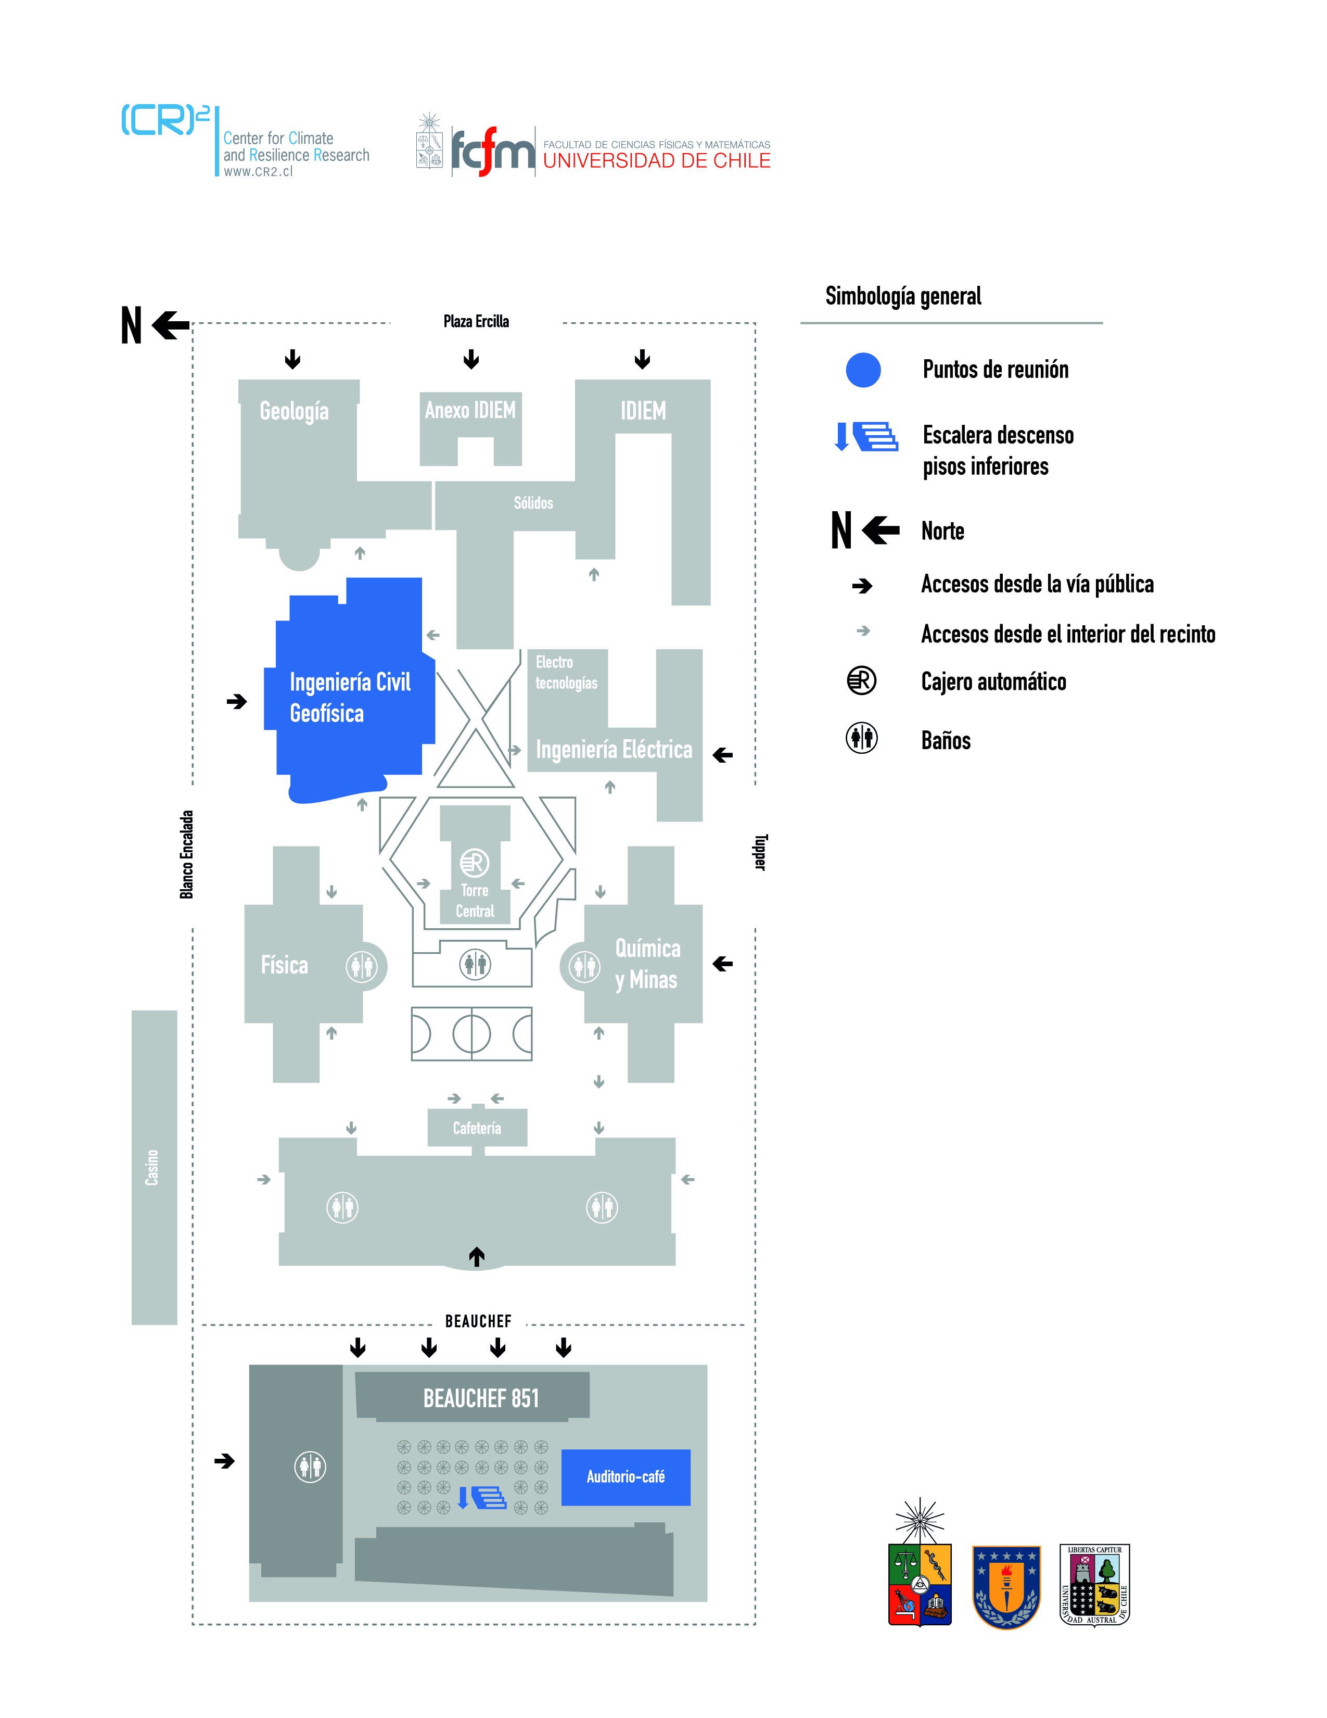

Panel Evaluador Externo

La Comisión Evaluadora está conformada por:
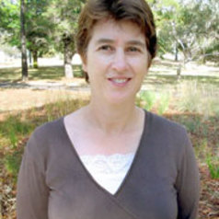 | Dr Helen Cleugh is Deputy Director of CSIRO Oceans and Atmospheric, delivering world-class research on significant national and international challenges in observing, understanding, and predicting our atmospheric, climate, and marine systems and their interactions with human activities.  http://www.csiro.au/news/newsletters/SIROSCOPE/2009/March09/htm/Spotlight/CMAR_Helen.htm
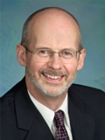 | Dr. Thomas Pedersen was appointed Executive Director of the Pacific Institute for Climate Solutions beginning September 1, 2009. His previous positions included Dean of Science (2003-2009), Professor of Oceanography and Director of the School of Earth and Ocean Sciences at the University of Victoria (2002-2003), and Associate Dean, Research for the Faculty of Graduate Studies at the University of British Columbia (2000-mid2002). Pedersen holds a degree in geology from UBC and a PhD in marine geochemistry from the University of Edinburgh. He is a fellow of the Royal Society of Canada and of the American Geophysical Union. He is an internationally recognized authority on ocean chemistry, has published extensively in the field of paleoceanography, and has longstanding interests in climate change issues and the application of government policy to climate-change mitigation and adaptation.  http://pics.uvic.ca/about/staff  Participó en la evaluación del CR2 al momento de su adjudicación.
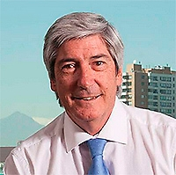 | Dr. Arturo Squella Serrano es Químico y Licenciado en Química de la Universidad de Chile, y posee un Doctorado en Química de la Universidad de Huelva, España.  Profesor Titular de la Universidad desde el año 1991, se ha desempeñado en docencia de pregrado desde el año 1975 en las asignaturas de Electroquímica, Electroquímica Aplicada, Físico-Química y Físico-Química Farmacéutica, entre otras, para las cuatro carreras de la Facultad. …  ….  es miembro del Consejo Superior de Desarrollo Científico y Tecnológico del Programa Fondecyt de Conicyt por el período 2013-2016.  http://www.uchile.cl/portal/presentacion/estructura/decanos-y-directores/8862/prof-arturo-squella-serrano
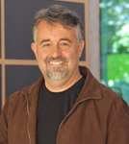 | Dr. José Miguel Cembrano Perasso. José specializes in tectonic, structure and geo fluids flow. Currently works as an Associate Professor at the Structural Engineering and Geotechnical Department from the Pontificia Universidad Católica de Chile where he is part of a new geosciences group. José has led numerous FONDECYT projects in topics such as Andean tectonic and geodynamics and developmental progressive fault systems course in magmatic / volcanic arches. Among its current research interests is understanding dynamic linking between crustal deformation and superior flow fluids, a relevant aspect to achieve the objectives of our Centre. Cembrano is the current President of the Chilean Geological Society (2010-2012). Geólogo, Universidad de Chile.Master of Science, Geology, Western Washington University, Estados Unidos.Ph.D. Earth Sciences, Dalhousie University, Canadá…es miembro del Consejo Superior de Desarrollo Científico y Tecnológico del Programa Fondecyt de Conicyt por el período 2015-2018.
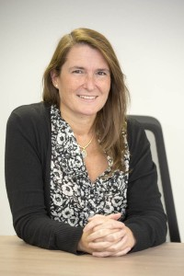 | María Eugenia Camelio. Directora (S) Programa FONDAP. Ingeniero Forestal de la Universidad de Chile. Realizó estudios de postgrado en The University of Idaho, Estados Unidos, donde obtuvo el grado de Master en Ciencias en Economía de los Recursos Naturales. Ha trabajado como investigadora en el Instituto Forestal en Santiago, como consultora en Forest Econ Inc, en Estados Unidos y participado en la ejecución de proyectos de investigación en el área forestal en la Universidad de Chile…. En el año 2004 se incorpora al Programa Centros de Investigación de Excelencia en Áreas Prioritarias (FONDAP) de CONICYT.

Invitad@s
La facilitación de las discusiones grupales del día 8 de Junio (Lunes) estará a cargo de los profesionales Rosa Osorio y Diego Arana.

Participantes del CR2 en las reuniones del 8 y 9 de Junio

Inv. Principales
Nombre | Apellido | Institución | Línea | Lunes | Martes
Laura | Farías | UDEC | BGC | SI | SI
Laura | Gallardo | UCH | MOS | SI | SI
René | Garreaud | UCH | CD | SI | SI
Antonio | Lara | UACH | ECO | SI | SI
Pilar | Moraga | UCH | HD | SI | SI

Inv. Asociad@s
Nombre | Apellido | Institución | Línea | Lunes | Martes
Paulina | Aldunce | UCH | HD | SI | SI
Duncan | Christie | UCH | CD | SI | SI
Ricardo | De Pol | UDEC | BGC | SI | SI
Mauro | González | UACH | ECO | SI | SI
Nicolás | Huneeus | UCH | MOS | SI | SI
Fabrice | Lambert | PUC | MOS | SI | SI
Patricio | Moreno | UCH | CD | SI | SI
Laura | Nahuelhual | UACH | HD | NO | SI
Axel | Osses | UCH | MOS | SI | SI
Maisa | Rojas | UCH | MOS | SI | SI
*Roberto Rondanelli (UCH, BGQ) vía skype

Inv. Adjunt@s
Nombre | Apellido | Institución | Línea | Lunes | Martes
Beatriz | Diez | PUC | BGQ | SI | SI
Mauricio | Galleguillos | UCH | ECO | SI | SI
Eugenia | Gayó | UDEC | BGQ | SI | SI
Paulo | Herrera | UCH | CD | SI | SI
Carlos | Jara | UACH | ECO | SI | SI
Christian | Little | UACH | ECO | No | Sí
Italo | Masotti | UV | BGQ | SI | SI
Rodrigo | Villa | UMAG | CD | SI | SI
Mauricio | Zambrano | UFRO | CD | SI | SI
Anahí | Urquiza | UCH | HD | SI | SI
*Gustavo Blanco (UACH, HD) asiste vía skype

Post doctorand@s
Nombre | Apellido | Institución | Línea | Lunes | Martes
Catalina | Aguirre | UCH | MOS | SI | SI
Juan Pablo | Boissier E. | UCH | BGC | SI | SI
Deniz | Bozkurt | UCH | MOS | SI | SI
Cinthya | Ramallo A. | UCH | CD | SI | SI
Catherine | Van den Hoof | UCH | CD | SI | SI
Mariela | Yévenes | UDEC | BGC | SI | SI
Carlos | Zamorano | UACH | ECO | SI | SI

Estudiantes/Ayudantes
Nombre | Apellido | Institución | Línea | Lunes | Martes
Maria del Pilar | Aparicio | UDEC | BGC | SI | SI
Gabriel | Araya | UCH | HD | SI | SI
Carlos | Ardissoni | UCH | CD | SI | NO
Ivo | Balic | UCH | CD | SI | SI
Constanza | Becerra | UACH | ECO | SI | SI
Mónica | Bello | UCH | CD | SI | SI
Matías | Bravo | UCH | MOS | NO | SI
Angela | Bustos | UACH | ECO | SI | SI
Camila | Carrasco | UCH | HD | SI | SI
Enrique | Cruz | UACH | ECO | SI | SI
Mindy | Fuentes | UCH | HD | SI | SI
Sebastián | García | UDEC | BGC | NO | SI
Julio | Hasbún | UCH | HD | SI | SI
Adolfo | Henríquez | UCH | MOS | SI | SI
Katherine | Indvik | UCH | HD | SI | SI
Gloria | Lillo | UCH | HD | SI | SI
David | Lobos | UACH | ECO | SI | SI
María Sol | Meckieve | UCH | HD | SI | SI
Víctor | Merino | UDEC | BGC | SI | SI
Alejandro | Miranda | UFT | ECO | SI | SI
Carolina | Morano | UMAG | CD | SI | SI
Priscilla | Nowajewski | UCH | MOS | SI | SI
Andrea | Orfanoz | UCH | MOS | SI | SI
Cristian | Pino | UCH | CD | SI | SI
Dharma | Reyes | UDEC | BGC | SI | SI
Giovanni | Testa | UDEC | BGC | SI | SI
Ignacio | Vera E. | UACH | ECO | SI | SI
Josefa | Verdugo | UDEC | BGC | SI | SI
Marcela | Vidal | UCH | HD | SI | SI

Personal de Apoyo
Nombre | Apellido | Institución | Línea | Lunes | Martes
Miguel | Aróstica | UCH | T | SI | SI
Claudia | Isla | UCH | T | SI | SI
Cecilia | Montecino | UCH | T | SI | SI
Francisca | Muñoz | UCH | T | SI | SI
Nicole | Tondreau | UCH | T | SI | SI

Temas integradores (interdisciplinarios) según la propuesta en Mayo 2012

Water scarcity in Northern and Central Chile
Among the several issues that can limit the Chile’s development, scarcity of fresh water is identified as an outstanding problem. In a country that still bases its economic growth in the exploitation of natural resources, water is much required in agriculture, mining and hydro-power, as well as for human consumption. The increasing demand of water resources is in collision course with the scarcity of this element in north-central Chile. The northern part of the country (18-30S) holds most of the mining activity along the Atacama desert, arguably the driest place on earth with less than 10-20 mm/year. The only input of water there is the convective rainstorms that occur over the high Andes during summertime (the so-called Bolivian winter) feeding small creeks and recharging the aquifer system of Pampa del Tamarugal. Winter storms become more frequent as one moves southward, but annual rainfall in central Chile does not exceed 500 mm for the most part. Fortunately, much of the winter precipitation contributes to the seasonal snow cap of the subtropical Andes, which melting during spring-summer support the river flow that is used in agriculture.
If the balance between water supply and water demand is nearly tie in present day, the future looks worrying. On the one hand, economic growth implies increasing demand even though usage efficiency is enhanced. On the other hand, climate models consistently project a substantial decrease of the precipitation over central Chile (33-40S), extending southward the water-stressed region. The reduction, relative to present conditions, can be as large as 30-40% under a high GHGs emission scenario (A2) for the end of the century (Fuenzalida et al, 2007). We need to sharp our projections of the hydrological cycle during the 21st century. This implies the use of more advanced, higher-resolution modeling tools to gauge the long-term trends produced by anthropogenic climate change (MO) but also a better assessment of the natural variability of the climate system, including interannual and interdecadal fluctuations (CD). Use of paleo-climate data (e.g., tree rings, lake sediments) will be an important tool to determine the typical amplitude and recurrence of longer term climate fluctuations, since they are poorly represented in the short historical records. Also, a careful analysis of the current legal framework for water resources is in place.
- We need to properly transfer the projected changes in climate drivers (precipitation, temperature) into hydrological change. CR² researchers have already contributed to project mean changes of surface hydrology (river runoff), but much work is needed in assessing changes in extreme events and subsurface resources (ground water). Within the CD component of our center we plan to estimate present and future recharge rates to understand groundwater systems in two pilot basins in Northern Chile.
- The projected changes in water resources (trends and variability) will be employed by the ECO group to assessing impacts in agriculture and natural vegetation communities. Likewise, the HD group will use this information to better quantify economic and social impacts, and eventually to propose changes in the legal system to better cope with the increased scarcity of water resources.
- CD in conjunction with BGC and HD will assess the question of reliability and trends in camanchaca as a non-conventional source of water for human consumption.

Urban sprawl in Central and Southern Chile
Urbanization constitutes worldwide a major and growing driver of global change (Zhu et al, 2012 and references therein), and so is also the case for urban centers in Chile and elsewhere in South America (Gallardo et al, 2012). Urban centers affect the regional climate in several ways. They perturb the atmospheric flow and significantly alter the surface energy and moisture balances (e.g., Hidalgo et al, 2008). Large cities concentrate population, transportation needs, energy and goods consumption, etc., leading to large emissions of CATs. These emissions affect the radiative balance, either directly or indirectly, regionally and globally (e.g., Butler and Lawrence, 2009). The climatic impacts of cities in Central and Southern Chile are further enhanced by the nearness of coastal upwelling areas allowing changes in cloud properties, biogeochemical processes in the surface ocean, and atmospheric oxidative capacity (Cf Section 2.1). Moreover, the expected drying of Central Chile may lead to a southward shifting of key agricultural activities, and population strengthening the pressures derived from the use of the territory in Southern Chile. Here again, it must be pointed out that large urban centers may offer effective means to mitigate climate change (e.g., Parrish and Zhu, 2009).Therefore an overarching focus of our proposal is to design effective measures to simultaneously control air pollution (photo-oxidants, particles, etc.) and to reduce climate change drivers (GHGs, aerosols, etc.). All research areas convened in this proposal are relevant to this end.
- HD will address which are the needed changes to our legal bodies in order to provide a coherent and common policy framework for air quality and climate change (e.g., Bond, 2007; Arneth et al, 2009). Also, HD will examine plausible future socio-economic scenarios required for building adequate urban and industrial emission scenarios. HD contributions in terms of mapping formal and informal institutions to better design the required win-win options, and to avoid cultural and social implementation pitfalls will be fundamental.
- BGC, ECO and MO will provide understanding, models and observations to account for emission and removal of CATs and other tracers, the ways in which they interact with radiation and clouds, surrounding land and aquatic ecosystems, and very importantly, the ways in which urban areas per se perturb the atmospheric flow. CD and MO will contribute with climate change scenarios modulating these phenomena over time. Also, this will in turn allow exploring the manner in which the health of people is concomitantly affected by air pollution in a changing climate (Romero-Lankao et al, 2012), a matter of highest interest under HD.
- BGC, ECO and CD will examine to what extent changes in coastal upwelling may alter primary production and thereby pelagic fisheries but also how subtle changes associated to land use changes may affect habitat-forming species, fish diseases, and in general food web dynamics.

Fast land-use changes in Central and Southern Chile
Chile, and particularly its central and south-central region, is well known by exhibiting substantial land changes as a result of human-induced processes (Donoso and Lara 1995; Echeverría et al. 2007a; Echeverría et al. 2011). Temperate forests in the south-central Chile are rapidly disappearing as a result of land use change. One of the most severely transformed landscapes in Chile has exhibited a deforestation rate of 5.4% per year, one of the highest rates reported in Latin America in the last decades (Echeverría et al. 2006). Landscape change in Chile has been related to diverse unsustainable practices such as forest logging to supply the increasing demand for wood and paper products, conversion of native forests and natural lands to pasturelands, crops and urban around as a result of human-set fires, high grading and other practices (Armesto et al. 2010; Lara et al. 2002; Lara et al. 2010). These actions have led to a loss of biodiversity (Hechenleitner et al. 2005; Newton 2007; Simonetti 2011) and ecosystem services (Lara et al. 2009; Little et al., 2009), and an increase in invasive species (Quiroz et al. 2009). Therefore, our work will focus on:
- Within this context, ECO will pursue the design of landscape arrays that are optimal to fulfill certain goals of goods and ES and their location. This will be jointly addressed with HD and MO.
- ECO and HD will define the time frames, rates, costs of the recovery of water provision as an ES from ecological restoration in watersheds in Southern Chile.
- A third objective will be the assessment of reduced precipitation predicted from climate models (CD and MO) for Central and Southern Chile on water provision as an ES from watersheds, considering different climatic and land-use scenarios.
- In collaboration with BGC and MO, ECO will quantify the potential fertilization and acidification that may occurs over Southern Chile in connection with urban growth. This is of outmost importance for expected changes in agriculture, and forestry.

Itinerarios Valdivia.

Nombre | Apellido | Institución | Llegada | Salida
Constanza Karime | Becerra Rodas | UACH | 07/06/2015 | 09/06/2015
Angela | Bustos | UACH | 07/06/2015 | 09/06/2015
Duncan | Christie | UCH | 07/06/2015 | 09/06/2015
Enrique | Cruz Tagle | UACH | 07/06/2015 | 09/06/2015
Mauro | González | UACH | 06/06/2015 | 09/06/2015
Carlos | Jara | UACH | 03/06/2015 | 09/06/2015
Antonio | Lara | UACH | 07/06/2015 | 10/06/2015
Christian | Little | UACH | 09/06/2015 | 10/06/2015
David | Lobos | UACH | 07/06/2015 | 09/06/2015
Laura | Nahuelhual | UACH | 08/06/2015 | 09/06/2015
Ignacio | Vera E. | UACH | 07/06/2015 | 09/06/2015
Carlos | Zamorano | UACH | 07/06/2015 | 10/06/2015

Itinerarios Concepción.
Nombre | Apellido | Institución | Llegada | Salida
Ricardo | De Pol | UDEC | 07/06/2015 | 10/06/2015
Laura | Farías | UDEC | 07/06/2015 | 10/06/2015
Sebastián A. | García L. | UDEC | 07/06/2015 | 10/06/2015
Eugenia | Gayo H. | UDEC | 07/06/2015 | 10/06/2015
Víctor | Merino | UDEC | 07/06/2015 | 10/06/2015
Dharma | Reyes | UDEC | 07/06/2015 | 10/06/2015
Giovanni | Testa | UDEC | 07/06/2015 | 10/06/2015
Josefa | Verdugo | UDEC | 07/06/2015 | 10/06/2015
Mariela | Yévenes | UDEC | 07/06/2015 | 10/06/2015

Itinerarios Valparaíso.
Nombre | Apellido | Institución | Llegada | Salida
Catalina | Aguirre | UCH | 08/06/2015 | 09/06/2015
María del Pilar | Aparicio | UDEC | 08/06/2015 | 09/06/2015
Ítalo | Masotti | UV | 08/06/2015 | 09/06/2015

Itinerario Punta Arenas.
Nombre | Apellido | Institución | Llegada | Salida
Carolina | Morano | UMAG | 07/06/2015 | 10/06/2015

Itinerario de Temuco
Name | Last Name | Affiliation | llegada | salida
Alejandro | Miranda | UFRO | 07/06/2015 | 09/06/2015
Mauricio | Zambrano | UFRO | 07/06/2015 | 10/06/2015

